EXP 1

IOT CENTRAL APPLICATION
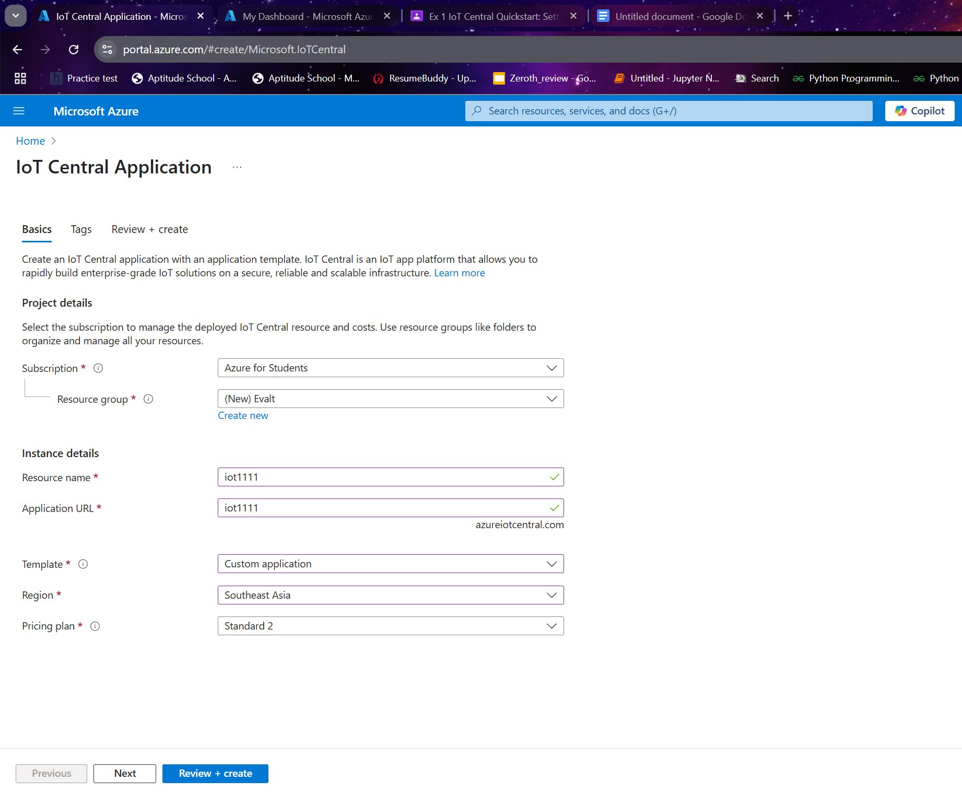
Review and create for validation

Create for final output
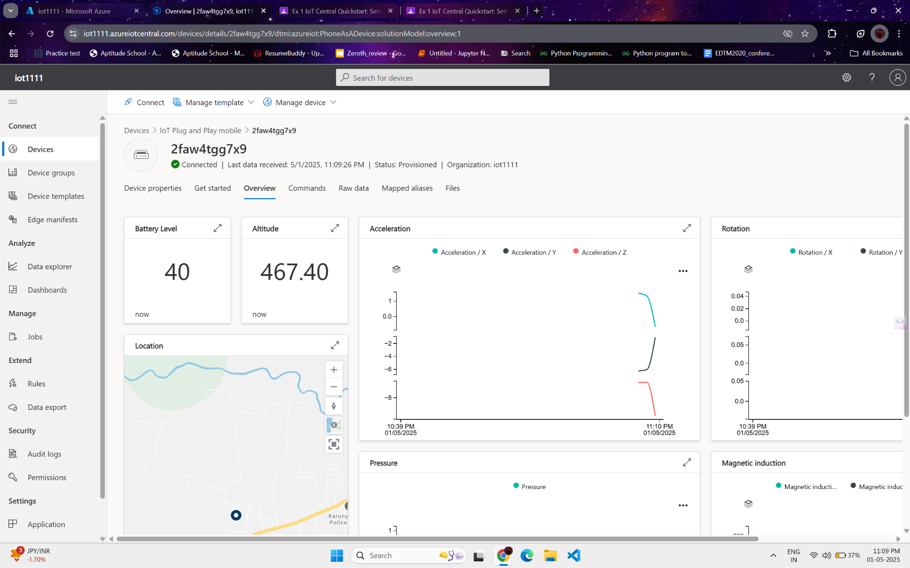

Ex. No. 2 Building and Deploying a Static Web App in Azure.
Static web application
Ex. No. 3 Deploying A Container Instance Using the Azure Portal

Container instances
Ex. No. 4 Building and Validating a Machine Learning Classification Model in Azure

Cloud&#39;s Sandbox Environment
Education

Leftside > learning resources > learning > create ml model > launch > train and evaluate regression model start >
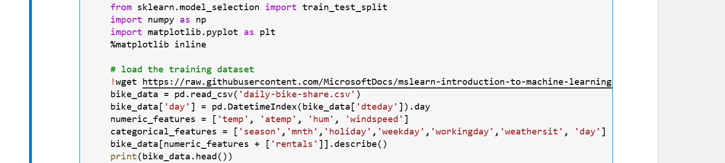
Ex. No. 5 Empirical Analysis and Validation of a Machine Learning Classification Model in

Azure Cloud

Virtual networks
Ipaddress > subnet > add subnet create > go to resources > setting > subnet > create subnet > go to search network security group > create > go to resources > setting > inbpud security rules > add >
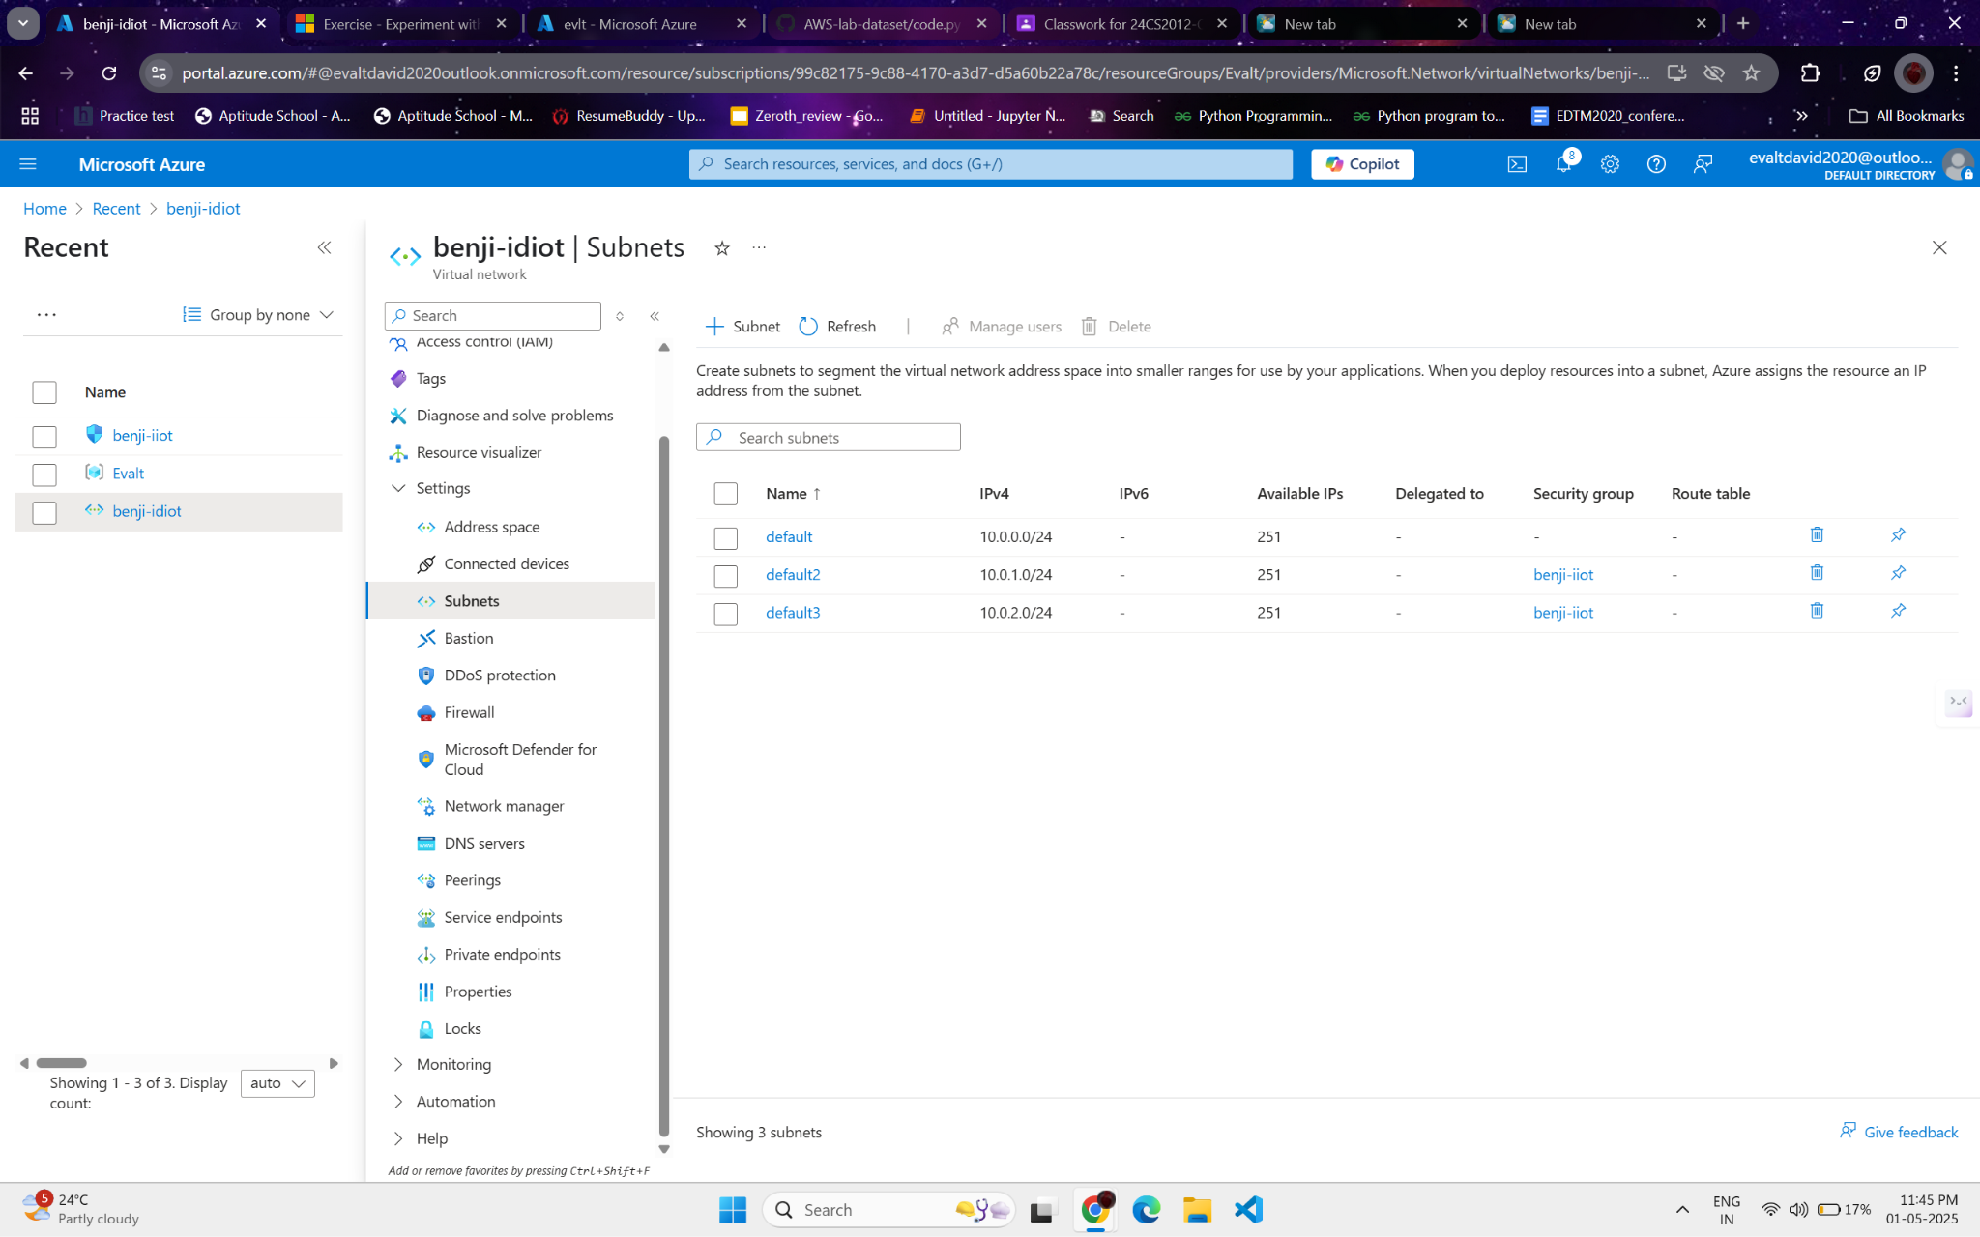
Ex. No. 7 Windows Virtual Machine Configuration and Connectivity in Microsoft

Azure
VIRTUAL MACHINE

